BUSINESS INTELLIGENCE AND TOOLS
EXPERIMENT - 2

Aim: To design and implement an end-to-end ETL (Extract, Transform, Load) pipeline using Microsoft Power BI's Power Query Editor, enabling the extraction of data from a real-world business dataset, application of transformation logic, and loading of cleansed data into a unified analytical model for reporting and decision-making.

Step-wise Solution

Step 1: Open Power BI Desktop
Launch Microsoft Power BI Desktop.
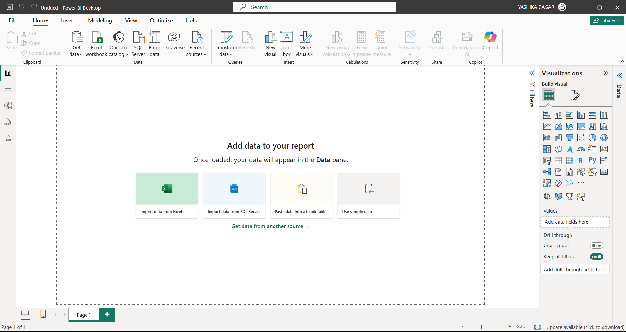

Step 2: Import the Dataset
- Home → Get Data → Excel Workbook
- Select Global Superstore Dataset.xlsx.
- Click Transform Data.
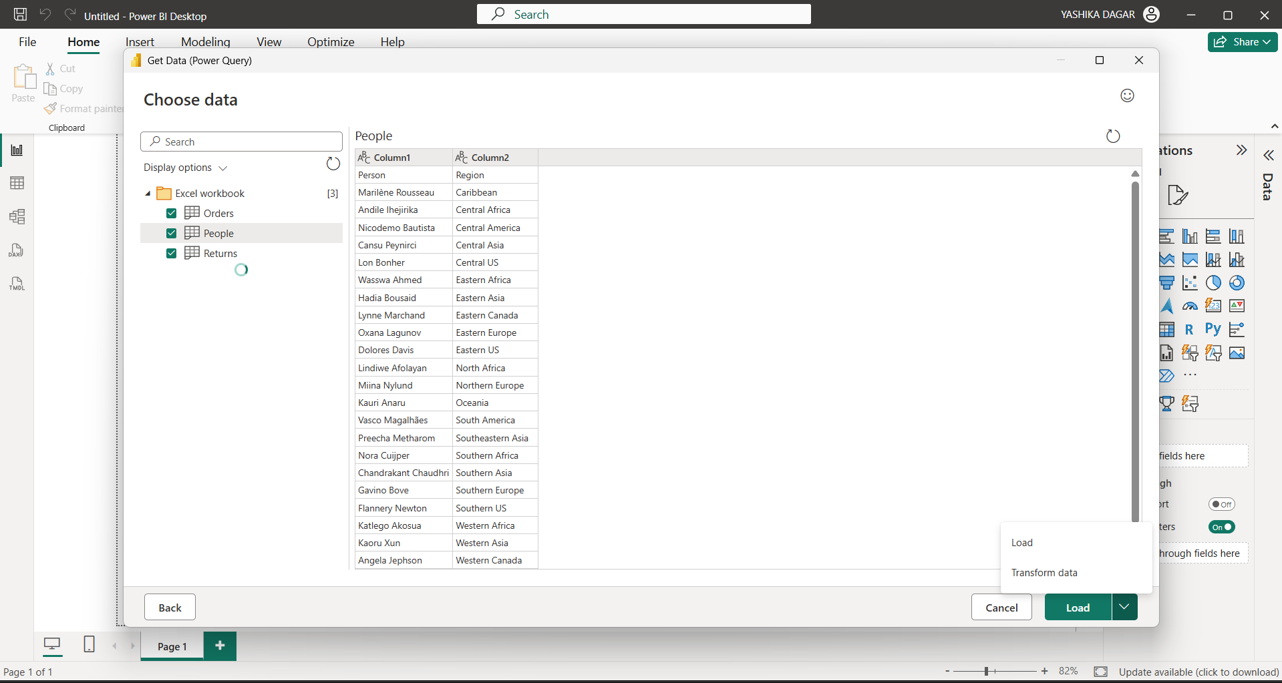

Step 3: Import Worksheets
Import the following worksheets:
- Orders
- Returns
- People
Verify that all tables appear in the Queries pane.

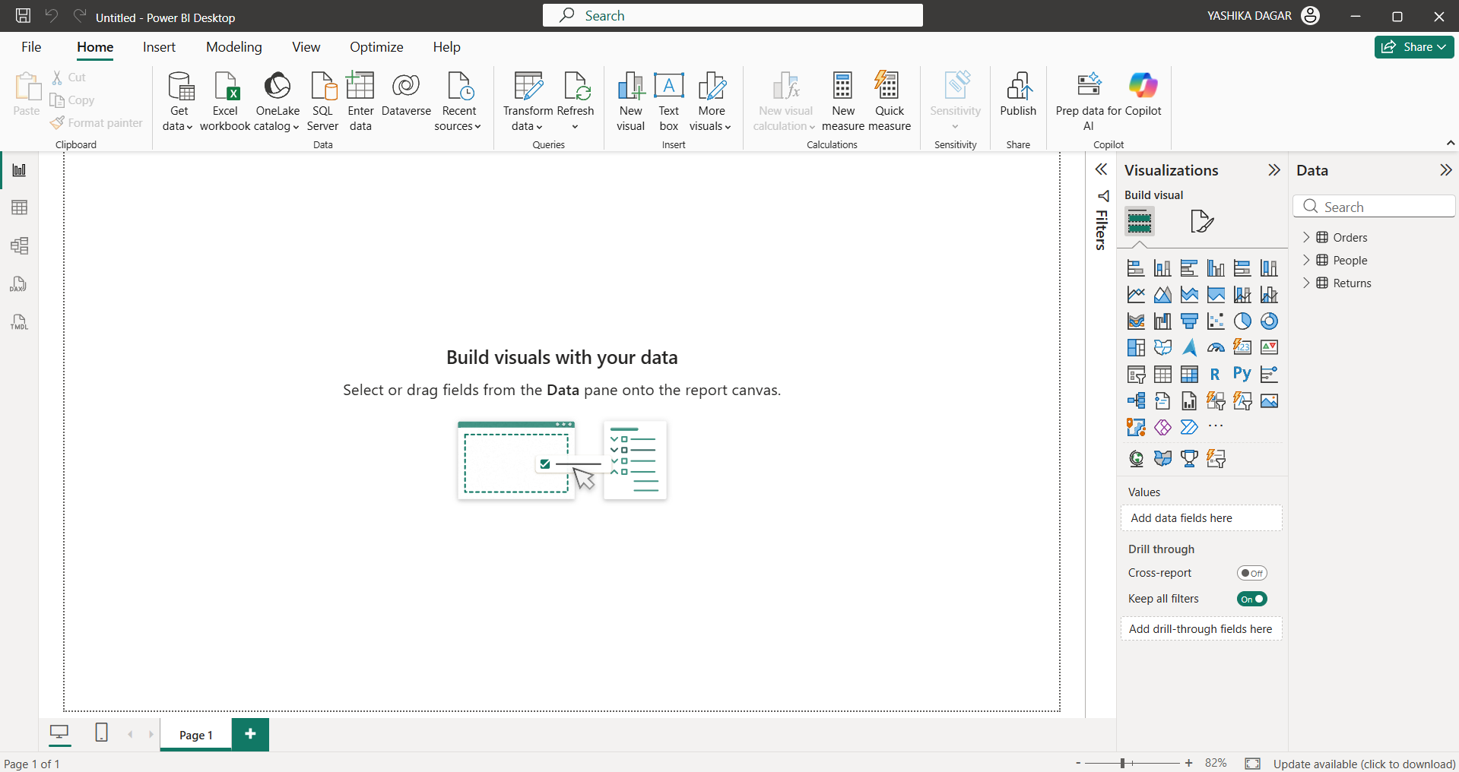

Step 4: Transform the Orders Table
Perform the following operations:
- Remove duplicate records.
- Remove blank rows.
- Verify and correct data types.
- Rename columns where required.
- Extract Year from Order Date.
- Extract Month from Order Date.
- Create a custom Profit Margin column.
- Standardize Region values.
- Standardize Segment values.

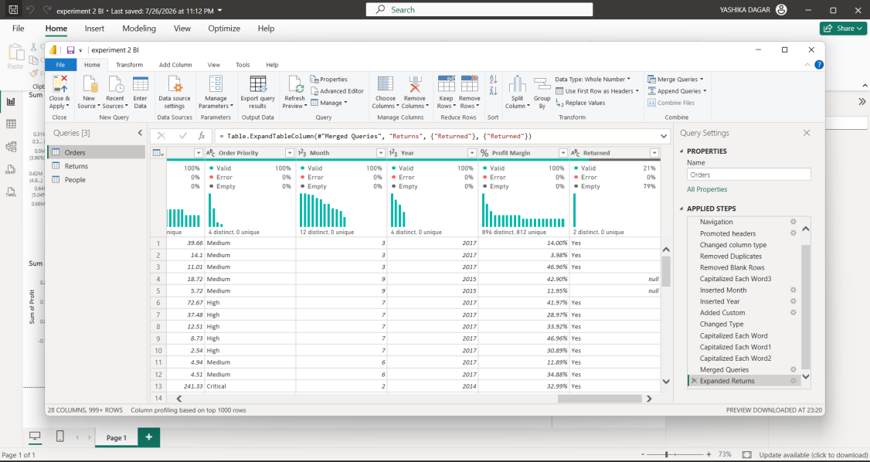

Step 5: Transform the Returns Table
Perform the following operations:
- Remove duplicate Order IDs.
- Capitalize each word.
- Rename columns.
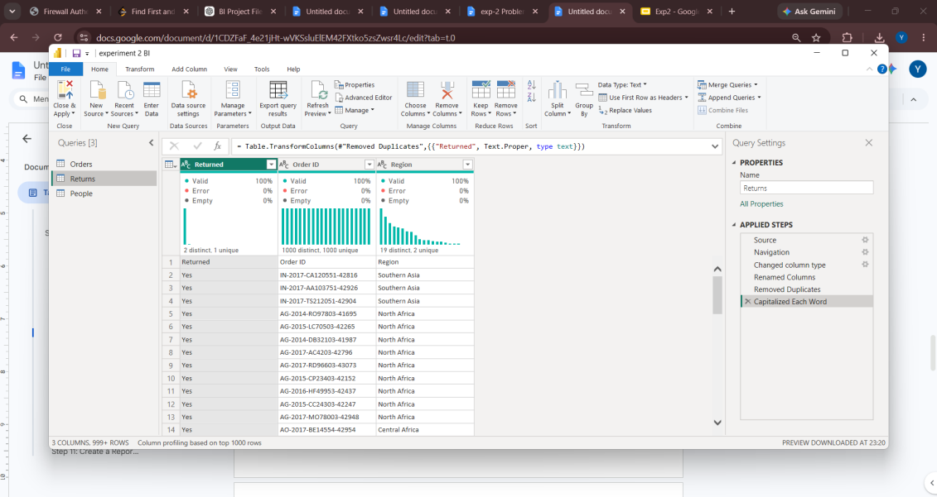

Step 6: Transform the People Table
Perform the following operations:
- Change column type.
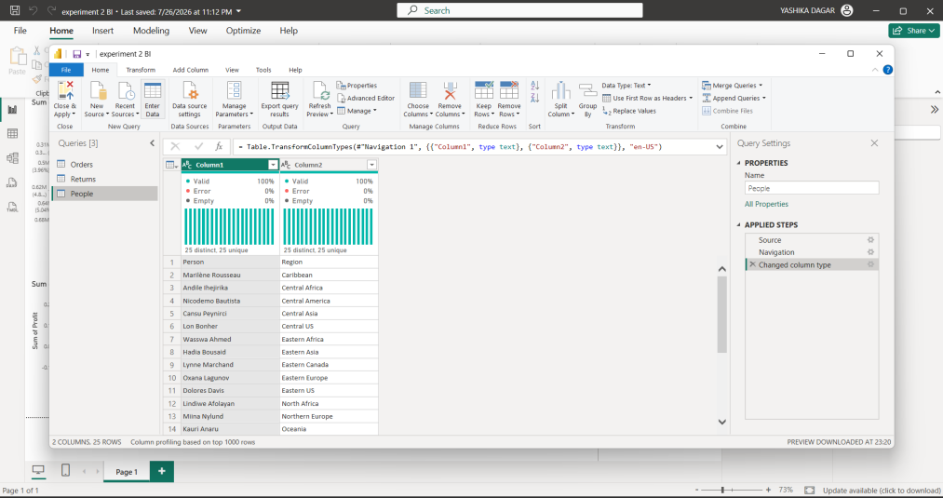

Step 7: Merge Tables
Merge Orders and Returns using Order ID.
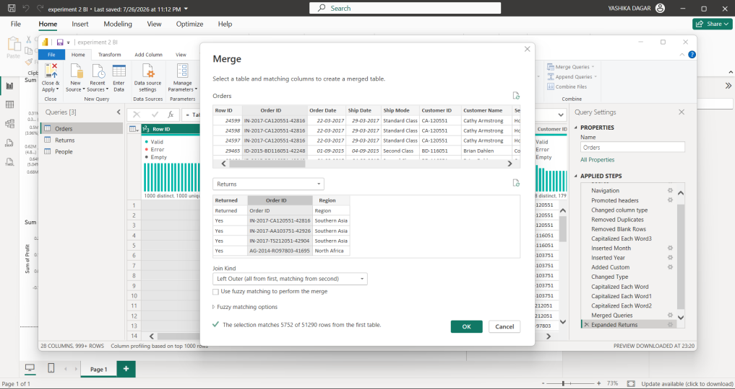

Step 8: Review Applied Steps
Review all transformation steps in Power Query Editor.
Click Close & Apply.
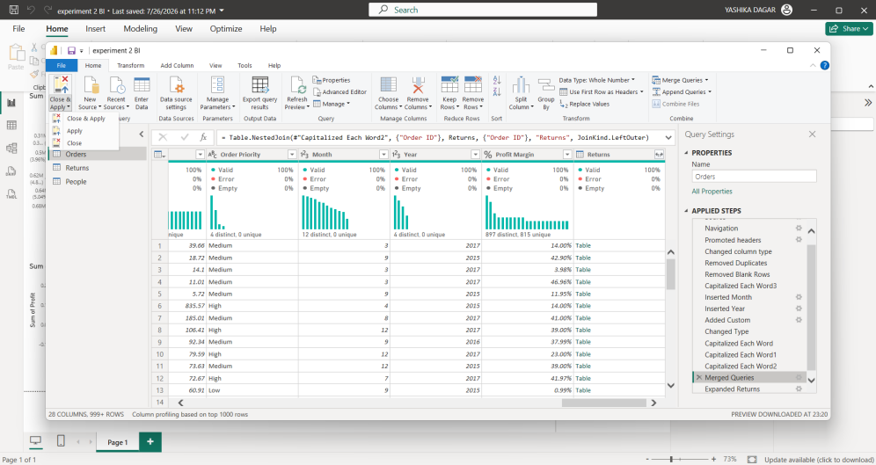

Step 9: Create Relationships
Create the following relationships:
- Orders ↔ Returns (Order ID)
- Orders ↔ People (Region)
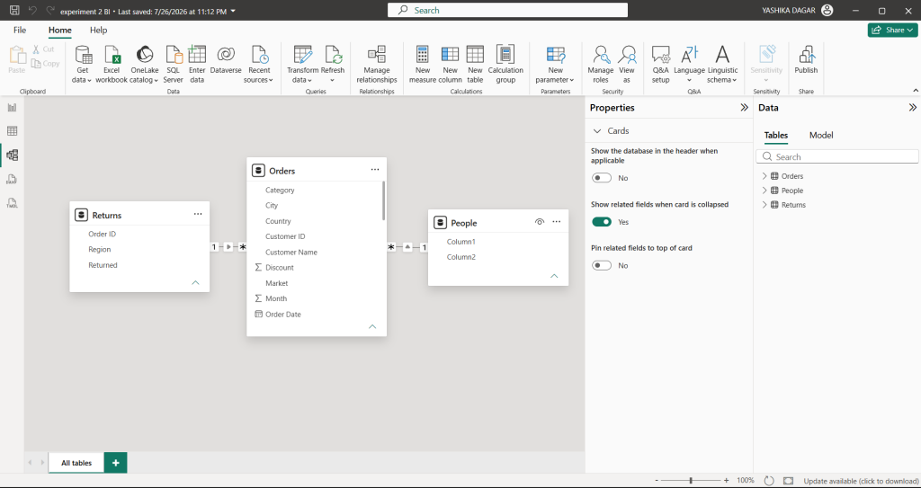

Step 10: Create DAX Measures
Create the following measures:
Total Sales = SUM(Orders[Sales])
Total Profit = SUM(Orders[Profit])
Profit Margin = DIVIDE(SUM(Orders[Profit]), SUM(Orders[Sales]))
Total Orders = DISTINCTCOUNT(Orders[Order ID])

Step 11: Create a Report Visualization
Create a simple report using fields from the related tables.
